CSIT314 Software Development Methodologies
Lab – Week 8
This exercise is about setting up resources and assigning resources to tasks using Microsoft Project. You will continue to work on the project that was created in the first lab in Week 2.

- Visit the following Web sites for a quick tutorial on setting up resources and assigning resources to task.

Set up resources: https://www.tutorialspoint.com/ms_project/ms_project_set_up_resources.htm

Resources to tasks: https://www.tutorialspoint.com/ms_project/ms_project_assign_resources_to_task.htm
- If you purchased the reference book MS Project 2016 Step by Step, refer to Chapters 5 and 6 for details.

- Enter the following resources to the project.

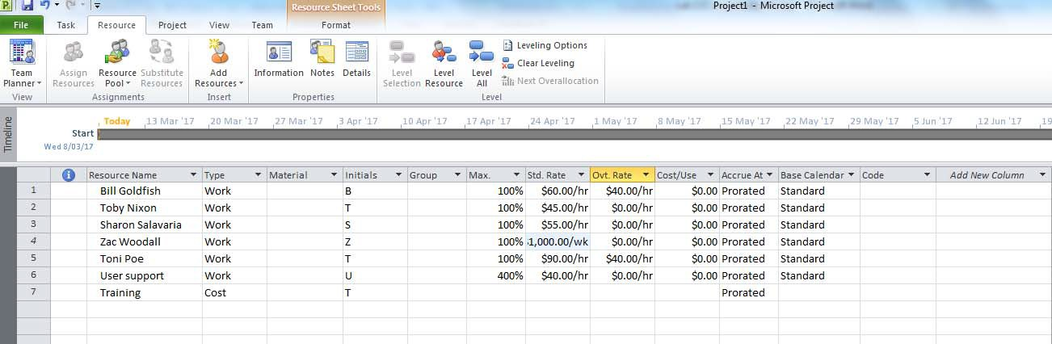

- Assign the following resources to tasks.
Task ID | Description | Resources
1 | Develop Business Plan | Toby Nixon
2 | Develop Project Charter | Sharon Salavaria
3 | Sign Project Charter | User support (100%)
4 | Develop strategic plan of software | Zac Woodall
5 | Develop strategic plan of hardware | Bill Goldfish

6 | Review strategic plans and determine if appropriate | Bill Goldfish
7 | Get senior management to approve strategic plan | Bill Goldfish
8 | Develop communication plan for strategic plan | Toni Poe
9 | Communicate approved strategic plan and documentation in printed and software format | Toby Nixon
10 | Create software system | Sharon Salavaria
11 | Install hardware components | User support (100%), Training ($1000)
12 | Review software system | Toby Nixon
13 | Review hardware installations | Bill Goldfish
14 | Prepare lessons learnt report | Zac Woodall
15 | Close project | Toby Nixon

- Answer the following questions:
  - What are the plan’s costs per task?
(On the View tab, in the Task Views group, click Other Views, and then click Task Sheet. On the View tab, in the Data group, click Tables, and then click Cost. The Cost table appears, replacing the Entry table.)
  - What are the plan’s costs per resource?
(On the View tab, in the Resource Views group, click Resource Sheet. On the View tab, in the Data group, click Tables, and then click Cost. The Cost table appears, replacing the Entry table.)
  - See resource assignment and other details grouped by task.
(On the View tab, in the Task Views group, click Task Usage. On the View tab, in the Data group, click Tables, and then click Summary. The Summary table appears, replacing the Entry table.)
  - See task assignment and other details grouped by resource.
(On the View tab, in the Resource Views group, click Resource Usage. On the View tab, in the Data group, click Tables, and then click Summary. The Summary table appears, replacing the Entry table.)
  - What is the total cost of the project?
  - Toby Nixon decides to work part-time. Thus, his max capacity becomes 50%. What would be the impact on the project duration and project cost?
  - Bill Goldfish is taking parental leave every Tuesday. What would be the impact on the project duration and project cost?
  - The project manager decides to add an extra resource (Toni Poe) to Task “Review software system”. If the task requires the same amount of work, what would be the impact on the project duration and project cost? If the task duration remains constant, what would be the impact on the project duration and project cost?
- Add the following new resources Room, type=Material and standard rate = $1500. Then assign this resource to the task “Install hardware components”.
- How is material type different from work type in resources?
- What is the revised project cost?
- Add the following fixed cost to the following tasks (hint: change the view to Cost Table): a. Develop strategic plan of hardware - $5000 b. Develop business plan - $1000 c. Install hardware components - $2000
- What is the revised project cost?
- Sharon Salavaria is given an increase in salary; her standard rate is now $65/hour, what is the revised project cost?
- Microsoft Project calculates total task work as the sum of the work that all assigned resources are to perform on the task. Before you proceed, make sure that you are at the Task Sheet view. On the View tab, in the Data group, click Tables, and then click Work. The work table appears, replacing the Entry table. What is the total work for the project?
- From the table, you can see the following columns Variance, Actual, Remaining, %W. Comp. (W. Comp. represents work completed) Why are the values shown for Work = Variance = Remaining?

